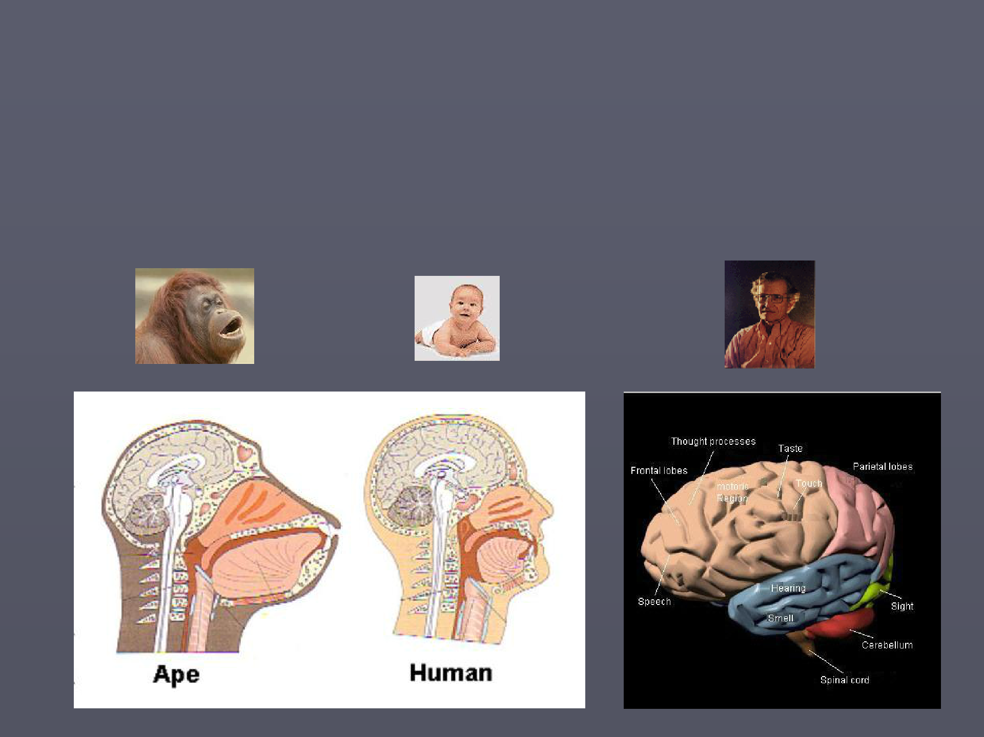
Psycholinguistics

Hauptseminar, SS 2014, Campus Essen

Raymond Hickey, English Linguistics


Why should one go to a seminar on psycholinguistics?

- Language acquisition tells about the manner in which we unconsciously learn language in our childhood. As second language acquisition it tells us about the way in which we can add another language to our existing knowledge of language. Second language acquisition furthermore offers insights into how two languages interact and illuminates the phenomenon of interference.

- First language acquisition reveals the stages through which we as very young children go through in learning our later native language. These stages teach us about what areas of language are central and what are less important.

- First language acquisition offers evidence for the hypothesis of many scientists that a certain amount of knowledge is innate (the nativist standpoint) and not simply learned by observation and/or habit (the empiricist standpoint).



- The order of stages is of relevance when looking at other areas of linguistics such as language change because the division of phenomena and categories into central and peripheral (acquisitional hierarchy) is reflected in the types of language change which are attested in the world's languages.

- The progression of language acquisition furthermore throws light on our cognitive development and as such help us to better understand our psychological makeup.

- On a broader level, language acquisition is concerned with learning more than one language. While monolingualism is often the rule in modern Western societies, most of the world's population is at least bilingual. This bilingualism has a social and an individual aspect.

Areas for presentations and term essays

- Language acquisition and related areas of development

►

►

►

- Biological maturation and language acquisition

- Linguistic and cognitive development

- Social aspects of language acquisition

- Acquisition of phonology/morphology

- Acquisition of syntax

►

►

- Single-word, two-word and complex sentences

- Syntax and later language acquisition (after 5)

- Acquisition of meaning

►

►

- Meaning relations

- Expanding vocabulary

Areas for presentations and term essays

- First and second language acquisition

►

►

- Comparing natural L1 and L2 acquisition

- Controlled and natural L2 acquisition

- First language acquisition and other areas of linguistics

- (psycholinguistics, language change, speech errors, language
- pathology, language universals)

- Acquisition of more than one language (natural bilingualism)

- Linguistic theory and language acquisition (empricism vs. generativism)

What is psycholinguistics?

Psycholinguistics is the study of language with reference to human psychology. It has a very broad scope but is frequently used with specific reference to processes of language acquisition, especially of one's first language. In the more general psycholinguistics covers the following areas

- Neurolinguistics (the study of language and the brain). This has a physical dimension to it and is the domain of neurologists concerned with impairments of language due to brain lesions, tumors, injuries or strokes. It also has an observational domain which is the concern of linguists. Here certain phenomena like slips of the tongue, various performance errors (due to nervousness, tiredness for instance) are examined for the insights which they might offer about the structure of the language faculty in the human brain.

- Language pathology The breakdown of language has been studied  intensively from at least two main angles. The first is that of medicine where attempts are made to help patients regain at least partially the ability to use language normally. Such patients are typically older people who have had a stroke (a burst blood vessel in the brain, in this case affecting the Broca or Wernicke areas) or younger people who have been involved in an accident (typically in a car or on a motorcycle) and have thus an impairment of the brain due to external injury. A third group is formed by patients who have had a tumor (cancerous growth) in the brain which impairs their speech pressing on either of the speech areas (fairly rare as a medical phenomenon though). Language disorders are known in linguistics and medicine as aphasia. There are many different types depending on the impairment which a patient shows.

- Broca's area A part of the brain — approximately above the left temple — called after its discoverer the French doctor Paul Broca and which is responsible for speech production.

- Wernicke's area A part of the brain which is taken to be responsible for the comprehension of language. It is located just above the left ear. Named after Karl Wernicke, the German scientist who discovered the area in the second half of the 19th century.

Speech errors

- The tip of the tongue phenomenon can be seen with non-pathological speakers and is characterised by a sudden block in lexical retrieval and which is released again for no apparent reason. Slips of the tongue involve the involuntary and unintended switching of elements among words of a sentence. Normally the onset or rhyme of adjacent syllables are switched and this phenomenon offers firm evidence for the validity of the syllable as a phonological unit.

Language acquisition

What can one learn?

- A child can learn any language. However, this is in general the language of the parents, but this does not have to be the case. The language which the child is exposed to in the first years of life is that which is learned.

- If more than one language is spoken in the environment of the child then the child learns these languages. Two languages are not rare, three or more are unusual, however. What is important for the child is that both languages are spoken to an equal extent in the environment - for instance by each of the parents - and that there are no major tensions in the relationship to the persons who speak these languages, otherwise the child will probably develop a general dislike of the language of this individual.


Language acquisition

This is a process which can take place at any period of one's life. In the sense of first language acquisition, however, it refers to the acquisition (unconscious learning) of one's native language (or languages in the case of bilinguals) during the first 6 or 7 years of one's life (roughly from birth to the time one starts school).

Characteristics of first language acquisition

- It is an instinct. This is true in the technical sense, i.e. it is triggered by birth and takes its own course, though of course linguistic input from the environment is needed for the child to acquire a specific language. As an instinct, language acquisition can be compared to the acquisition of binocular vision or binaural hearing.

- It is very rapid. The amount of time required to acquire one's native language is quite short, very short compared to that needed to learn a second language successfully later on in life.


- It is very complete. The quality of first language acquisition is far better than that of a second language (learned later on in life). One does not forget one's native language (though one might have slight difficulties remembering words if you do not use it for a long time).

- It does not require instruction. Despite the fact that many non-linguists think that mothers are important for children to learn their native language, instructions by parents or care-takers are unnecessary, despite the psychological benefits of attention to the child.

What is the watershed separating first and second language acquisition?

Generally, the ability to acquire a language with native speaker competence diminishes severly around puberty. There are two suggestions as to why this is the case. 1) Shortly before puberty the lateralisation of the brain (fixing of various functions to parts of the brain) takes place and this may lead to general inflexibility. 2) With puberty various hormonal changes take place in the body (and we technically become adults). This may also lead to a inflexibility which means that language acquisition cannot proceed to the conclusion it reaches in early childhood.

Definitions and distinctions

- Acquisition is carried out in the first years of childhood and leads to unconscious knowledge of one's native language which is practically indelible. Note that acquisition has nothing to do with intelligence, i.e. children of different degrees of intelligence all go through the same process of acquiring their native language.

- Learning (of a second language) is done later (after puberty) and is characterised by imperfection and the likelihood of being forgotten. Learning leads to conscious knowledge.

- FIRST LANGUAGE ACQUISITION This is the acquisition of the mother tongue. Chronology is important here (see below). The degree of competence acquired may vary from individual to individual and may be checked by later switching to another language. Note that language acquisition is largely independent of intelligence, although individuals can and do differ in their mastery of open classes such as vocabulary.

- BI- AND MULTILINGUALISM This is the acquisition of two or more languages from birth or at least together in early childhood. The ideal situation where all languages are equally represented in the child's surroundings and where the child has an impartial relationship to each is hardly to be found in reality so that of two or more languages one is bound to be dominant.


- SECOND LANGUAGE ACQUISITION This is the acquisition of a second language after the mother tongue has been (largely) acquired. Usually refers to acquisition which begins after puberty, i.e. typically adult language acquisition. Sometimes replaced by the term further language acquisition.

- ERROR This is an incorrect feature in language acquisition which occurs because of the stage at which the child is at a given time (acquisition in as yet incomplete). Errors are regular and easily explainable. For instance the use of weak verb forms for strong ones or the overapplication of the s-plural to all nouns in English would be examples of errors. Such features tend to right themselves with time when the child appreciates that many word classes contain a degree of irregularity.

- MISTAKE Here one is dealing with a random, non-systematic and usually unpredictable phenomenon in second language learning. Mistakes are sometimes termed 'performance errors' to emphasise that they arise on the spur of the moment when speaking and are not indicative of any acquisitional stage.

- COMPETENCE is the abstract ability to speak a language, i.e. knowledge of a language independent of its use.

- PERFORMANCE is actual use of language. Its features do not necessarily reflect characteristics of performance, for example, when one is nervous, tired, drunk one may have difficulties speaking coherently. This, however, does not mean that one cannot speak one's native language.

Acquisition and learning

- Second language acquisition refers to a further language which is acquired after the first, usually after primary school. The acquisition of a second language never reaches the degree of proficiency of the first. The reason for this is that children start too late, in fact they are usually teenagers before being exposed to the second language. After puberty one cannot learn a second language as well as a first one, no matter how much time one invests in this. In this connection linguists generally make the distinction between acquisition - for the first language - and learning - for the second language after childhood.

Conditions of acquisition

- NATURAL This is characterised by continuous exposure to language data. This data is not ordered, i.e. the (child) learner is exposed to the performance of adult speakers of the language he/she is acquiring. There is little if any feedback to the acquirer with regard to this intake.

- CONTROLLED This is intervallic if not to say sporadic. Furthermore it takes place against the background of another language, usually the first language (L1) of the learners. In exceptional cases acquisition can be both natural and controlled, i.e. where one obtains formal instruction (or gives it one to oneself) and lives in an environment where the target language is spoken. Controlled acquisition is further characterised by an ordered exposure to the data of the language.

- GUIDED LANGUAGE ACQUISITION This is an intermediary type between the two just discussed and is characterised by prescriptive corrections on the part of the child's contact persons, i.e. mother, father, etc. Corrections show the transfer of adult grammars to children whereas natural language acquisition shows the gradual approximation of the child's grammar to the adult's.

- Note that a child is not corrected as often by his/her mother as one might
imagine. Self-correction is most common (but not immediate) due to two factors. Most broadly speaking, because of lack of communication (here immediate correction may take place) and secondly by consistently hearing correct usage on the part of the mother, the child eventually drops his/her incorrect forms, which while perhaps communicatively effective, are grammatically wrong. It is also true that children do not learn language just from the mother. If siblings are present, then they too form a source of input for the child. And siblings do not correct others or simplify their language for the younger ones among them.

The logical problem of acquisition

- The logical problem of language acquisition is that it would seem impossible to learn anything about a certain language without first already knowing something about language in general. That is the child must know what to expect in language before he/she can actually order the data he/she is presented with in his/her surroundings and ascribe meanings to words he/she encounters.

- THE EVIDENCE OF DEAF CHILDREN Deaf children start by babbling and cooing but this soon peters out because they have no linguistic input. However, they would seem to seize on other communication systems and if people in their surroundings use sign language then they pick this up. The interesting point here is that the children usually learn the sign language more perfectly than the people from which they learn it (note: sign language has grammar with inflections just as does spoken language). They are creative in this language and create sentence structures if these are not present in their input. This would seem to suggest that deaf children use sign language as a medium for activating their knowledge about language which is innate.



- THE EVIDENCE OF PIDGINS Children who have very poor input in their surroundings tend to be creative in their use of language. Any categories which they deem essential but which are not present in the input from their environment are then invented by the children. This has happened historically in those colonies of European powers where a generation was cut off from its natural linguistic background and only supplied with very poor unstructured English, Spanish, Dutch, etc. as input in childhood. Such input, known technically as a pidgin, was then expanded and refined grammatically by the children of the next generation and is known in linguistics as a creole. Here one can see that if the linguistic medium of their environment is deficient children create the structures which they feel are lacking, going on their own abstract innate knowledge of language.

- The implication of both the above cases is that children look for language and if they do not find it they create it somehow, so that they have a system of communication. In this sense language is a true instinct because it starts to develop of its own accord and does not need to be consciously triggered.

- IS THERE A LANGUAGE GENE? There is a pathological medical condition called Specific Language Impairment (abbreviated SLI) which covers a range of defects, all of which have in common that children continually make grammatical mistakes in their mother tongue, i.e. they would seem to be unaware of the existence of grammatical rules. Now as the Canadian linguist Myrna Gopnik has shown in her study of a family in Britain, some 16 of 30 members over three generations suffered from the defect. This would seem to imply that it is genetically transferred (it looks like a defective gene which is dominant in the family) which would also imply that the ability to grasp the rules of grammar in first language acquisition is genetically encoded.

- IS THE LANGUAGE FACULTY SEPARATE FROM OTHER COGNITIVE ABILITIES? There is one major piece of evidence that this is the case. Williams syndrome is a medical condition in which the patients are quite severly retarded, as both children and adults, and have difficulties counting properly or carrying out simple tasks like tieing their shoelaces. However, such people are good speakers of their native language and just show a slight tendency to overgeneralise (they might say speaked for spoke). They have a good command of grammatical rules which shows that their language faculty is intact. The implication of this is that our ability to speak language is separate from other cognitive abilities.

How is language transmitted?

- Language is obviously passed on from parents to their children. But on closer inspection one notices that it is the performance (in the technical sense) of the previous generation which is used as the basis for the competence of the next. To put it simply, children do not have access to the competence of their parents.

►

►

►

1) | Linguistic input from parents (performance) | >
2) | Abstraction of structures by children | >
- Internalisation (competence of next generation)

- The above model is the only one which can account for why children can later produce sentences which they have never heard before: the child stores the sentence structures of his/her native language and has a lexicon of words as well. When producing new sentences, he/she takes a structure and fills it with words. This process allows the child to produce a theoretically unlimited number of sentences in his/her later life.

- Note that certain shifts may occur if children make incorrect conclusions about the structure of the language they are acquiring on the basis of what they hear. Then there is a discrepancy between the competence of their parents and that which they construct; this is an important source of language change.

► Language acquisition for any generation of children consists of achieving mastery in four main areas, i.e. acquiring:

- A set of syntactic rules which specify how sentences are built up out of phrases and phrases out of words.

- A set of morphological rules which specify how words are built up out of morphemes, i.e. grammatical units smaller than the word.

- A set of phonological rules which specify how words, phrases and sentences are pronounced.

- A set of semantic rules which specify how words, phrases and sentences are interpreted, i.e. what their meaning is.

Competence and Performance

- competence According to Chomsky in his Aspects of the theory of syntax (1965) this is the abstract ability of an individual to speak the language which he/she has learned as native language in his/her childhood. The competence of a speaker is unaffected by such factors as nervousness, temporary loss of memory, speech errors, etc. These latter phenomena are entirely within the domain of performance which refers to the process of applying one's competence in the act of speaking. Bear in mind that competence also refers to the ability to judge if a sentence is grammatically well-formed; it is an unconscious ability.

- performance The actual production of language as opposed to the knowledge about the structure of one's native language which a speaker has internalised during childhood.


Stages of language acquisition

- One of the firmest pieces of evidence that language acquisition is genetically predetermined is the clear sequence of stages which children pass through in the first five years of their lives. Furthermore there are characteristics of each stage which always hold. For instance up to the two-word stage only nouns and/or verbs occur. No child begins by using conjunctions or prepositions, although he/she will have heard these word classes in his/her environment. Another characteristic is overextension. Children always begin acquiring semantics by overextending meaning, for instance by using the word dog for all animals if the first animal they are confronted with is a dog. Or by calling all males papa or by using spoon for all items of cutlery. The generalisation here is that children move from the general to the particular. To begin with their language is undifferentiated on all linguistic levels. With time they introduce more and more distinctions as they are repeatedly confronted with these from their surroundings. Increasing distinctions in language may well be linked to increasing cognitive development: the more discriminating the child's perception and understanding of the world, the more he/she will strive to reflect this in language.

- 0.0 - 0.3Organic sounds, crying, cooing

- 0.4 - 0.5Beginning of the babbling phase

- 0.10 - 1The first comprehensible words. After this follow one-word, two-word and many-word sentences. The only word stages is known as the holophrastic stage; Telegraphic speech refers to speech with only nouns and verbs.
3) | 2.6 | Inflection occurs, negation, interrogative
 |  | and imperative sentences
4) | 3.0 | A vocabulary of about 1000 words
5) | 5.0 | The main syntactic rules have been
 |  | acquired

These divisions of the early period of first language acquisition are approximate and vary from individual to individual.

Insights from language acquisition

Unconscious knowledge

- For the linguist the metaphor of the iceberg is very useful: nine tenths of language is under the surface. For instance, none of the present public would probably be in a position to list and describe the sentence structures of their native language. Nonetheless you use these hundreds of times each day in well-formed sentences. Perhaps a medical comparison might be helpful here: you use the muscles of your body constantly in order to move your limbs or to keep your balance while standing. You can do that without knowing how it works. But your central nervous system 'knows' how the muscles are innervated.

Insights from language acquisition

One can recognise here that there are two types of knowledge: knowledge which one can express in words - e.g. the rules of chess - and unconscious knowledge which is activated without reflection, for instance, when speaking your native language. Such unconscious knowledge is based on the internalisation of language structures which we extracted from our environment as children.

Input

Language in our surroundings

Action by child

(i) extraction of structures

(ii) storage in long term memory as

unconscious knowledge

Insights from language acquisition

Language as an instinct, as an innate faculty

- An instinct is a tendency to do something which when triggered in childhood cannot be rejected, it is not a matter of conscious decision. For instance, there is no adult who crawls around on all fours, we cannot refuse to walk upright because this is an instinct. The development of an instinct takes place immediately after birth and is completed quickly.

Insights from language acquisition

If one applies this view to language acquisition then one can maintain the following.

- No child makes a conscious decision to learn a language.

- No child has ever refused to learn the language spoken in his/her environment.

- Acquisition is unconscious and can be compared with the unfolding of other instincts, for instance that of binaural hearing or telescopic vision.

Linguists furthermore assume that we know what language is and how we are to react to it, i.e. by acquiring it. To put it simply: the language faculty is innate so that the child can immediately process the language he/she hears in the surroundings. The child must not wait for instructions from the parents before acquiring his/her native language.

Insights from language acquisition

The decline in the ability to learn language

In general one can maintain that after puberty the ability to acquire a language - in the technical sense of learning with native speaker competence - drops off radically and is never gained again. There are two major hypotheses about why this should be the case. The hypotheses may well be related to each other.

- Due to the lateralisation of the brain - shortly before puberty - the brain loses flexibility and receptiveness, at least for unconscious learning. By lateralisation one means the fixing of functions of the brain to one half only.

- With sexual maturity at puberty strong hormonal changes take place with humans. These lead to a reduction of the playful element which is typical of children. The spontaneous behaviour of children decreases drastically with the onset of puberty. A certain rigidity is characteristic of adults vis a vis children and this also affects the ability to learn languages.

Insights from language acquisition

What do we know at the end of the day?

Now we can view the stages of native language acquisition in more detail.

- Children hear fragments of language in their environment. They then abstract the underlying structures behind what they hear.

- Children then internalise the structure they gained - for instance the structures of sentences - and later on they use these when they wish to form new sentences without considering whether they have heard an actual sentence before or not. This process is called sentence generation in linguistics.

Contrasting features of first and second language acquisition

FLA

no conscious choice
very rapid
no instruction
high competence reached

SLA

choice made by learner
relatively slow
instruction is usual
competence attained varies greatly

Possible reasons for differences between FLA and SLA

SLA occurs against the background of FLA (interference hypothesis)

FLA takes place before puberty (adulthood)
FLA takes place before lateralisation of brain (just before puberty)

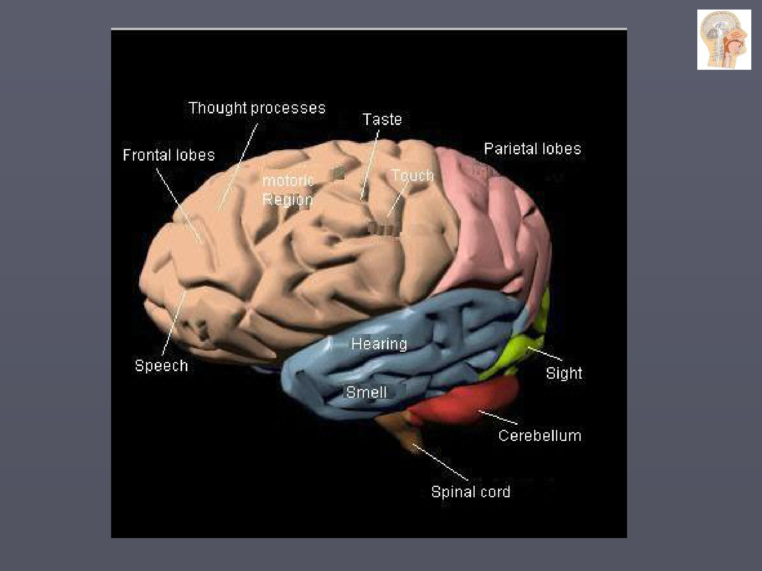

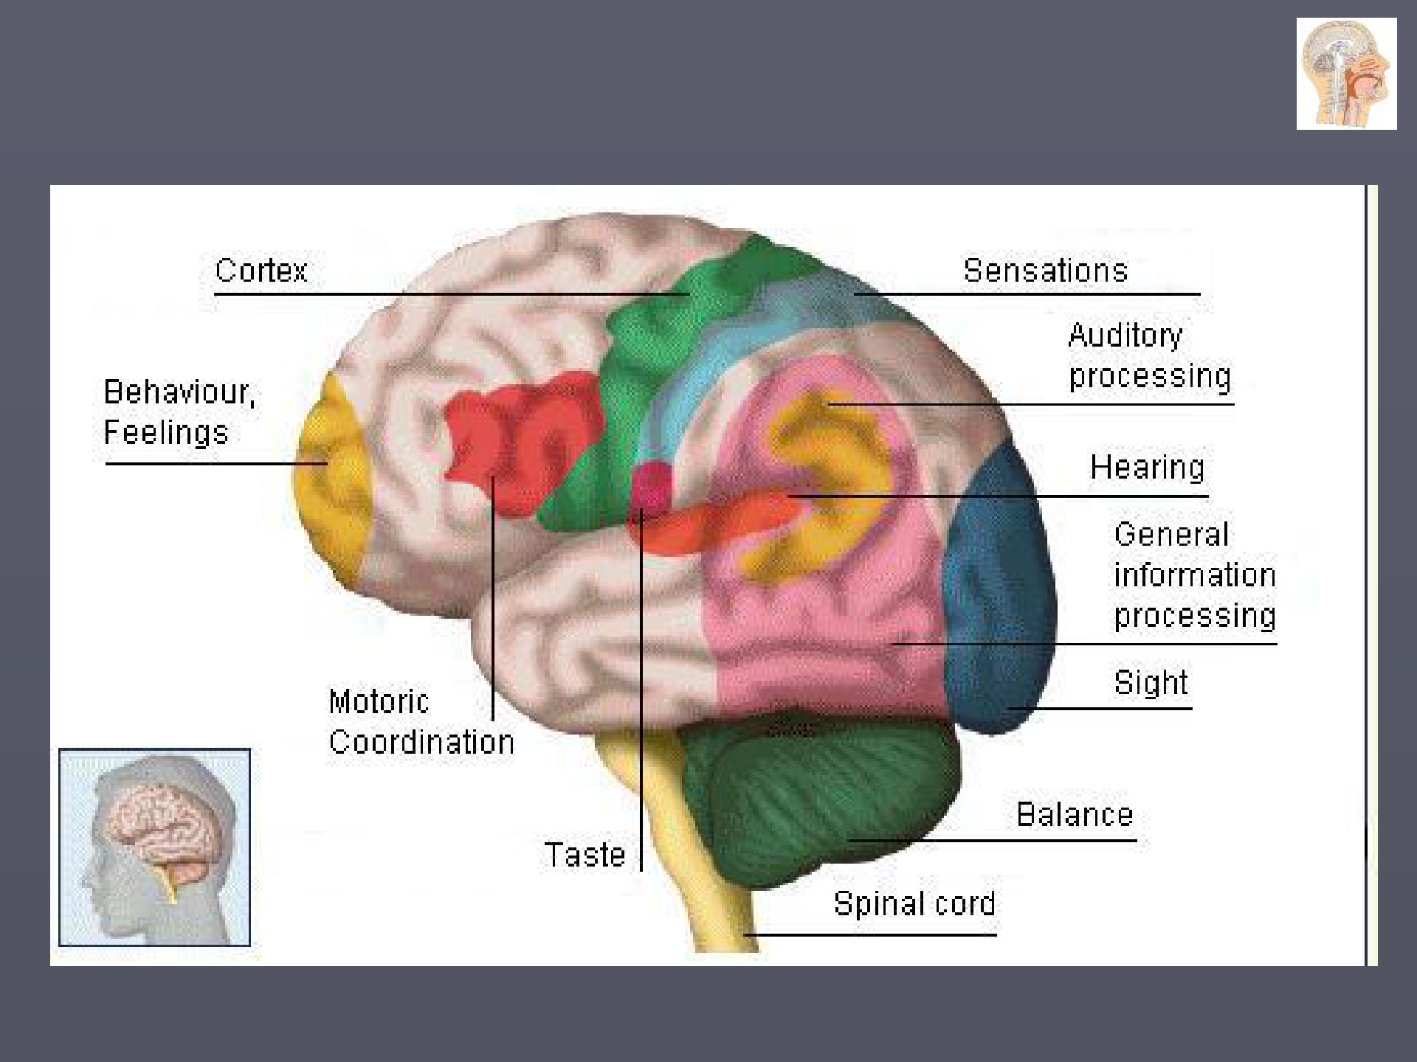

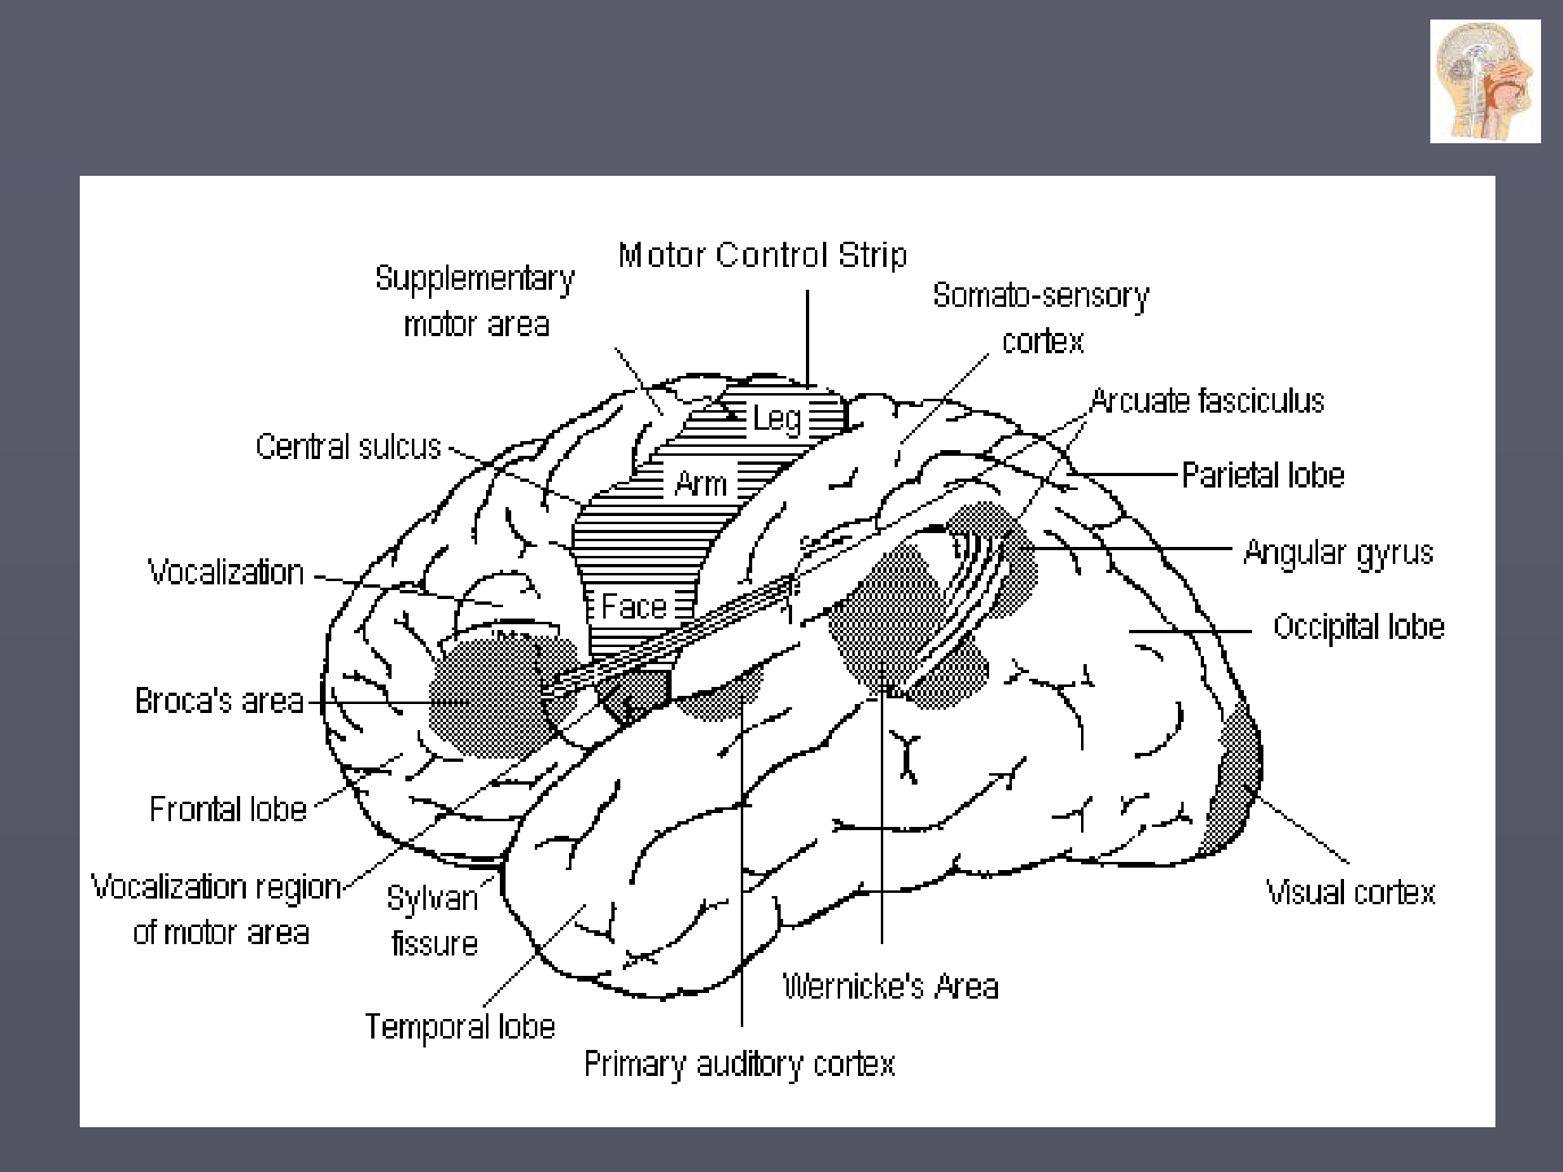

Recommended literature

Aitchison, Jean 1998. The articulate mammal. An introduction to psycholinguistics. London: Routledge.
Clark, Herbert H. 1996. Using language. Cambridge:
University Press.
Fletcher, Paul and Michael Garmon (eds) 1979 and later Language acquisition Cambridge: University Press.

Gregory, Richard L. (ed.) 1987. The Oxford companion to the mind. Oxford: University Press.

Lust, Barbara and Claire Foley (eds) 2004. Language acquisition: The essential readings. Malden, MA: Blackwell.
Steinberg, Danny 1993. An introduction to psycholinguistics.

London: Longman.

