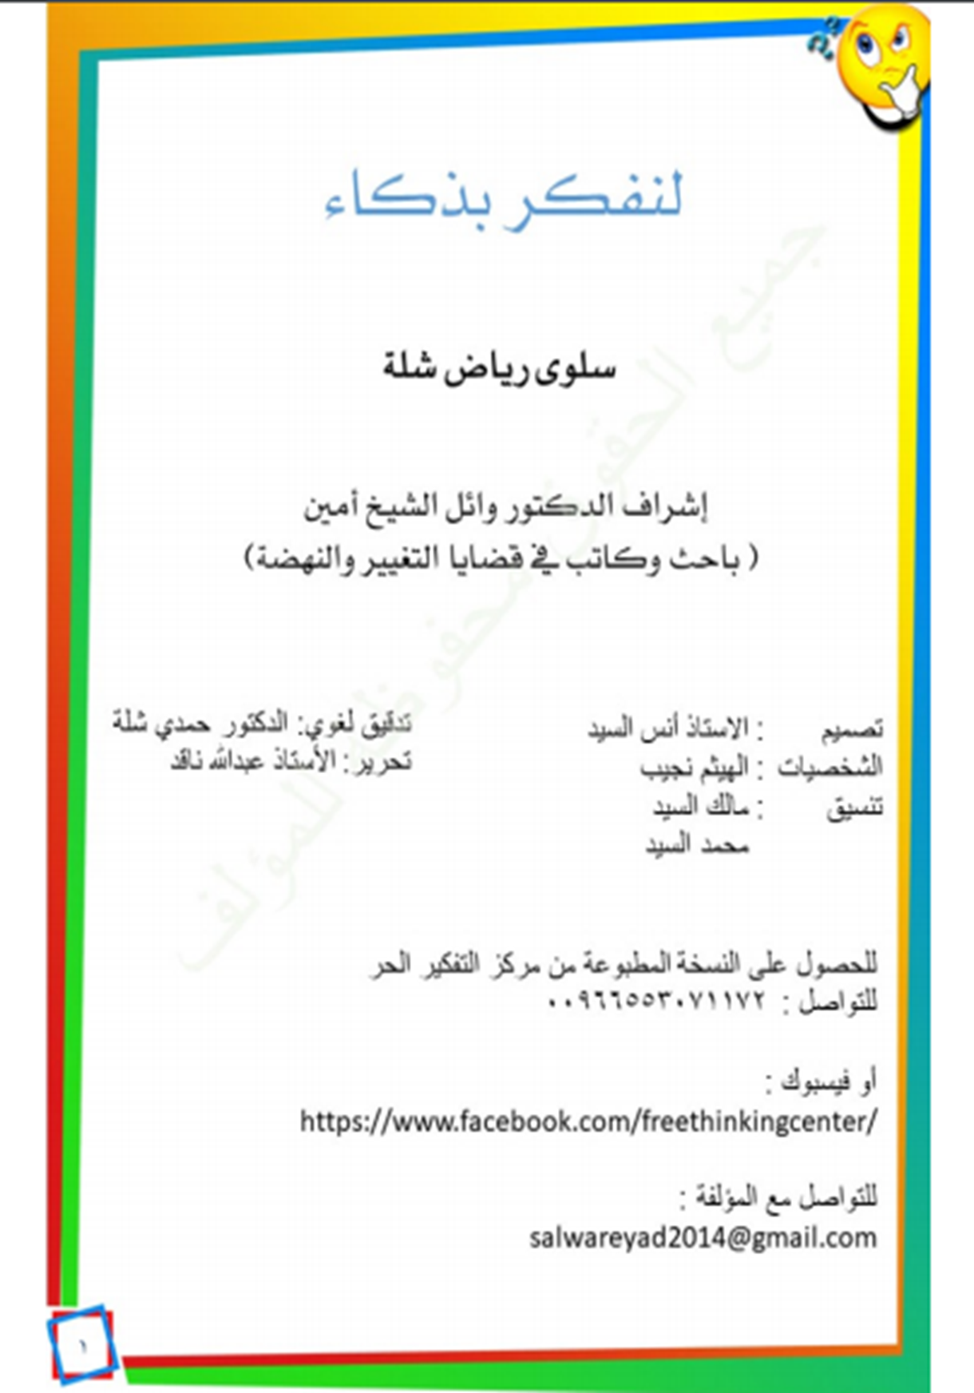
1
Dedication
To youth who are embarking on the adventure of life, including its problems, tribulations and intellectual, ethical, ideological battles in order to be wiser in building their visualizations of life and its vicissitudes, to get out of its mazes with the least damage and the most benefit, and to correct their way of thinking in understanding people and things around them.
To parents who are looking for an awareness-raising guide that can help them to discuss with their children a contrastive convincing debate. Thus, to give them a thinking method that will protect them from falling in life’s pitfalls such as blindly following what social media and the press dictate. These are dominating our children’s minds and reframing their thoughts anew.
To educators in schools and private clubs of both boys and girls, it helps them to build a generation that is aware and conscious to fulfill their responsibility of their jobs to the fullest extent.
To those who are willing to explore the methods of critical thinking; they can consider this book a small version and an introduction to this field of knowledge so that they dive into advanced and specialized books afterwards.

2
Introduction
We would all like to be smarter, to have more understanding and knowledge; we think think the way to achieve that needs memorizing information as much as we can.
But that’s wrong!
To be smarter means your way of dealing with information should be better and efficient.
To be smarter means your mind should work in a better way.
How can you reach that?
This is what is known as the thinking skills’ field, and the critical thinking is one of the most important skills. It is a complicated field that many people avoid studying because of its difficulty.
The writer, Salwa E-Chella, is facilitating some of the critical thinking concepts with an amazing method in order to make this book your first step to enter the critical thinking world. She uses exciting dialogues between two main characters to support her book.
“Moushakis”, the hasty boy and “Radjih”, the intelligent boy.
When you finish reading this book, I wish you would have a lot of fun, and you would become a smarter person. I hope you could apply what you have learned from this book in your life.
Dr. Wail Shaikh Amine

3
Dear the Reader,
I dedicate my book while seeing you young and brilliant offering this life energy and tracing your future with diligence which will provide you a hopeful way. However, the way to this future is full of experiences and difficulties. You will be exposed to situations that demand sagacity and intelligence, so you can solve problems. You will need wisdom to take your decisions, and you will be the only responsible for yourself and your decisions’ results whether they were positive or negative. How about training your mind how to think well in order to improve your competence, to develop your talents, to learn how to make the right decision, and solve problems?
There is a number of common mistakes that you may commit, but if you pay attention to them and train yourself to avoid them, your decisions would be more sensible a, people will not deceive you easily. Not everybody wishes you the best; there are certain people will try to convince you of what they want only for their own benefit. In this book, we have classified these common mistakes as “logical fallacies”. Critical thinking will teach us how to discover and uncover these fallacies, and show us how to think sensibly and how to look at the matter from different perspectives; so that our judgements would grow more accurate and sounder.
Moushakis, who has not learnt anything yet about critical thinking, will take us in a ride where he will fall in a lot of logical fallacies as a result of his hastiness. Whereas, our friend, Radjih, will help him to correct these mistakes. So, we should watch their behaviours from different windows and see plenty of situations where Radjih will try to correct them with diligence.
Let’s follow together my friends..

