University of Mohamed Khidher – Biskra Branch: Accounting
Faculty of economics, Commercial and Management Sciences Level: First (1) year Master

Exercises (series N° 04)
Exercise N° 01: Company « A » has provided the following information that related to the financial year ended.
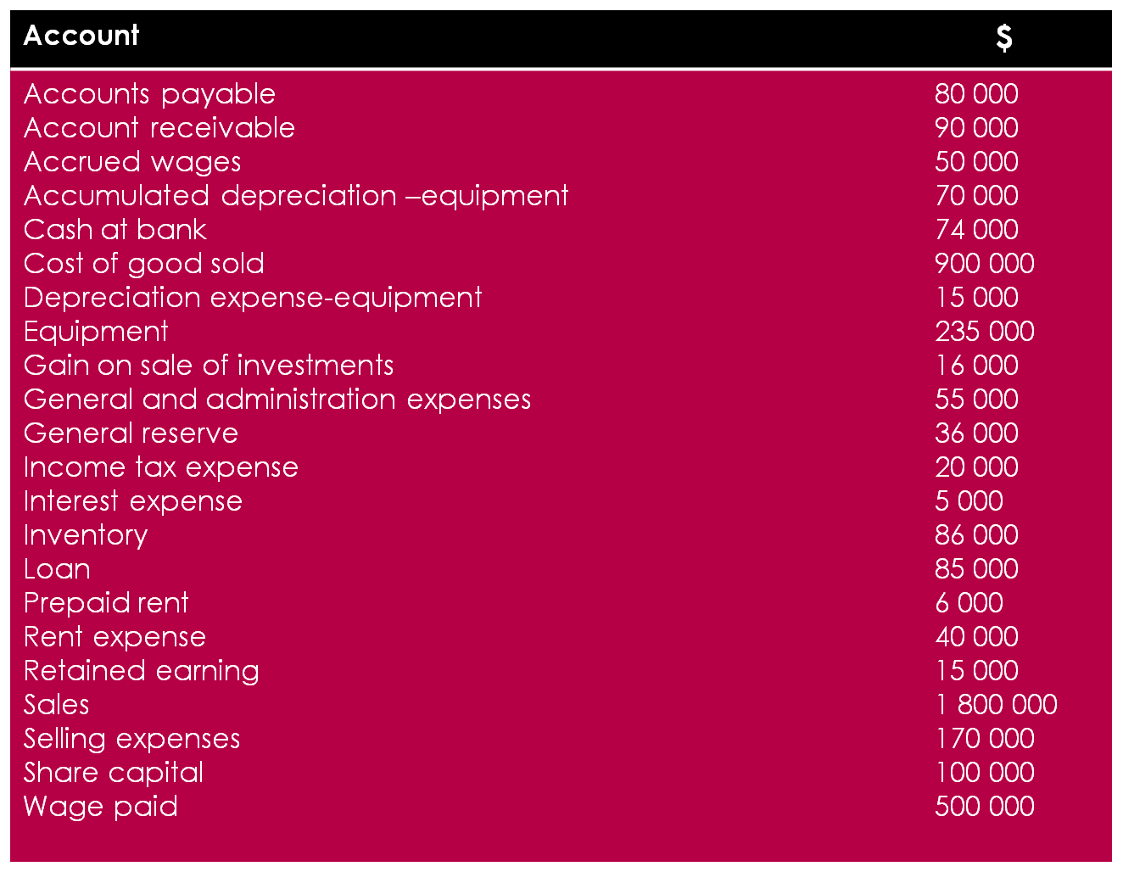
- Use the information in the above table to prepare an income statement for the company « A ».
- Use the information in the above table to prepare a Balance sheet for the company « A ».
Exercise N° 0 2: Collins computer Timeshare Company during May 2017.
- Purchased computer terminals for $520 000 from digital equipment on account.
- Paid $ 1000 cash for May rent on storage space.
- Received $ 14 000 cash from customers from contracts billed in April.
- Performed computer service for Schmidt Construction Company for $ 52400 cash.
- Paid central state power Co $511 000 cash for energy usage in May.
- Shareholders invested and additional $ 532 000 cash in the business.
- Paid the digital equipment for the terminal purchased in (1) above.
- Incurred advertising expense for May of $ 1100 on account.
Instructions: indicate with the appropriate letter whether each of the transactions above results in.
- An increase in asset and a decrease in asset.
- An increase in asset and an increase in equity.
- An increase in assets and an increase in liabilities.
- A decrease in assets and a decrease in equity.
- A decrease in assets and a decrease in liabilities.
- An increase in liabilities and a decrease in equity.
- An increase in equity and a decrease in liabilities.
Exercise N° 03
- Double accounting system owes its origin to:
- Lucas Pacioli b) Adam Smith c) Kohler d) Karl Marx
- Which of the following statement is correct
- Assets – equity = liabilities b) liabilities + equity =assets
- c) liabilities + assets = equity d) assets – liabilities = equity
- Which of the following is a liability?
- Machinery b) loan from bank c) building d) cash
- According to accounting equation asset equal to
- Equity + liabilities b) liabilities – equity c) equity – liability
- Which of the following is long term liability:
- Bond payable b) salary payable c) rent payable d) account payable
- A total of expenses and net profit is equal to:
- Net loss b) revenue c) net profit d) gross profit
- Excess of expenditure over income is:
- Net loss b) revenue c) net profit d) gross profit
- Excess of assets over equity is called:
- Income b) expense c) liability d) profit
- ………… is called liabilities
- Machinery b) loan c) owner’s equity d) notes receivable
- Creditors means
- Who has to pay the amount b) who purchases good on credit c) who sells goods on credit d) owner of business
- Asset and liabilities both will increase by:
- Drawing of owner b) payment of suppliers c) purchase of furniture on credit d) purchase of goods on cash
- Owner’s equity of business is $150 000 which is three-fourth of total assets, then the assets would be:
- $100 000 b) $ 200 000 c) $300 000 d) $400 000
- Total liabilities of a business are $ 50 000 which are two-third of total asset, then total assets would be:
- $ 95 000 b) $ 85 000 c) $75 000 d) $ 65 000
14) Every business transaction affect
a) exactly two account
b) at least one account
c) not more than two account
d) at least two account

Common Account Titles: Income Statement
Account Title | Type of Account
Sales | Revenue
Cost of Goods Sold | Cost of Goods Sold
Advertising Expense | Operating expense
Amortization Expense | Operating expense
Insurance Expense | Operating expense
Rent Expense | Operating expense
Salaries and Wages | Operating expense
Utilities Expense | Operating expense
Marketing Expense | Operating expense
Gain on sale | Other Income
Interest Income  Rental income | Other Income
Loss on sale | Other Expense
Interest Expense | non operating expense
Income Tax | Taxes (non operating expense)
Common Account Titles: Balance Sheet
Account Title | Type of Account
Cash | Current Assets
Marketable Securities | Current Assets
Account Receivable | Current Asset
Inventory | Current Assets
Prepaid expenses  Defered expense | Current Assets
Allowance for Doubtful Accounts | Current Assets
Buildings | Fixed Assets
Equipment | Fixed Assets
Leasehold Improvements | Fixed Assets
Accumulated Depreciation | Fixed Assets
Land | Fixed Assets
Investment in Bonds | Investments
Investment in Stocks | Investments
Goodwill | Intangible Assets
Intellectual Property | Intangible Assets
Accounts Payable | Current liability
Cash Dividends Payable | Current Liability
Income Tax Payable  Interest payable | Current liability
Capital Stock | Shareholders Equity
Common Stock | Shareholders Equity
Dividends | Shareholders Equity
Paid-In Capital | Shareholders Equity
Preferred Stock | Shareholders Equity
Retained Earnings | Shareholders Equity
Treasury Stock | Shareholders Equity

