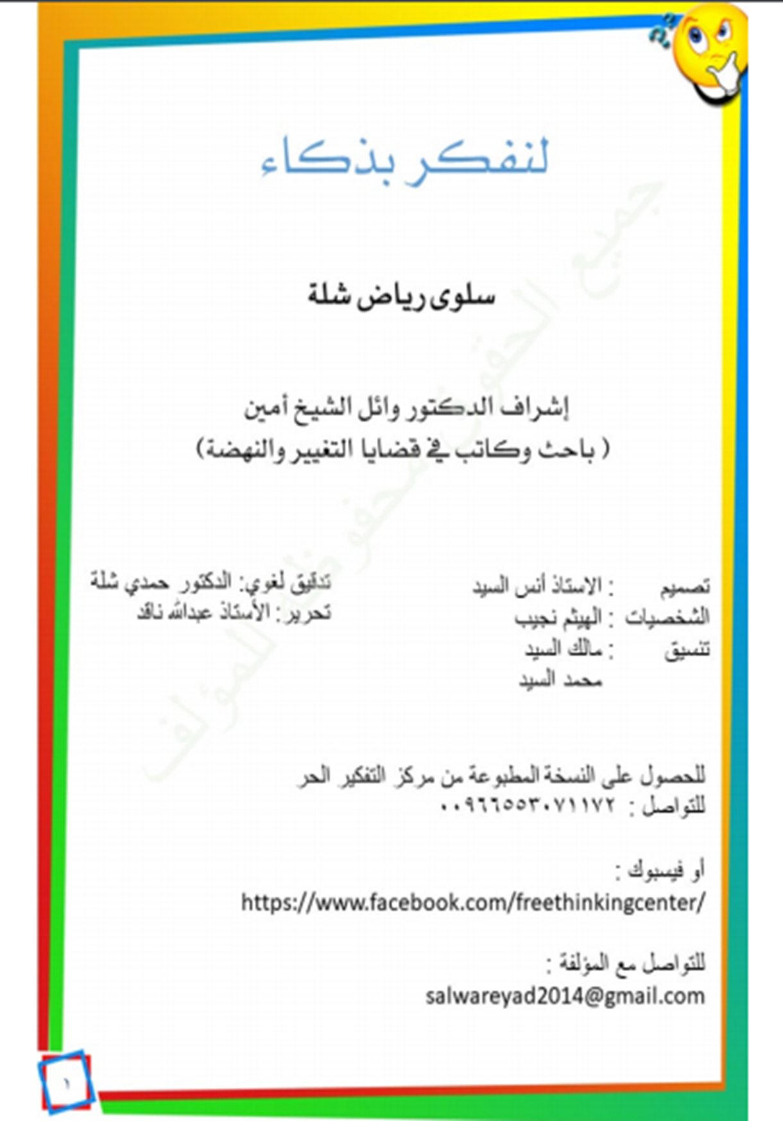

1

**My name is Mouchakis**

**I’m a good but hasty boy, I act impetuously**

**My name is Rajeh,**

**I’m a smart boy who thinks with wisdom,**

**I act sensibly**

**We will live many situations with these two boys. Mouchakis will make us laugh sometimes, he may have problems though. However, Rajeh will always be there to rectify his friend’s ideas and thinking, hoping to get him out of trouble and protect him from his impetuosity and rashness in the future.**



2

**The Ad hominem fallacy**

Being able to judge new people in our lives through their morals and actions is very important ; we build relationships with friends who have good morals and avoid thoses with moral flaws. We deal with trustworthy people and avoid the thief…We deal with the honest people and avoid liars…but what if you meet a person who has shortcomings, but who is speaking sensibly and is giving you a piece of advice ! Would you accept it from him/her ?

This fallacy shows the mistake of « attacking the person who is speaking instead of discussing the idea he/she is presenting » and seeing how valid it is, as an idea. The mistake is when we criticise his/her behaviour or shortcoming, investigate his/her past, remember his/her mistakes, instead of listenning to the content of his/her speech and focus on what is right or wrong in it !

**Accept the truth, regardless of the speakers’ faults or shortcomings today, take from them what is right and leave everything else.**

Let’s look at the situation of Mouchakis with his friend Tarik.

Mouchakis felt angry as Tarik refuse to accompany him to a fast-food restaurent.

**Tarik** : fast food causes obesity and chornic illnesses. We can just eat in tonight.

**Mouchakis** : I saw you insult your brother yesterday, and now you want me to listen to your advice ?

**Radjeh** : Let us overlook Tarik’s past mistakes…Is it not true that he is right ? Discuss the information he gave you rather the stick to his faults. We’re all human, we make mistakes, and we differ in our ideas and opinions. If we do that, we will live at peace with society as a whole.

3

**Libya TV** : Playing with electronic devices for long hours is one of the causes of distraction and lack of focus.

**Mouchakis** : Libya TV is the worst Tv in channel in terms production, it is not popular at all. Plus, its owner is a bossy man. I don’t care at all about their opinions.

**Radjeh** : Libya TV channel, depite all of its nagative aspects, is right about this piece of information, don’t you think so my friend ?

One of the types of the « ad hominem » fallacy is : **circumstantial ad hominem**

One may attack someone becasue of certain circumenstnaces that they are going through. That i sis why it is called « circumstantial ». One may criticise the fact that the person i sis sick, is travelling, is rich or poor, or where he works or where he lives.

**These circumstances surely do not affect our opinions, but do not make our opnions valid when they’re not,as they do not invalidate our opnions when they are valid.**

Let’s go back to Mouchakis…

**Omar** : You have to go to the gym Mouchakis, in order for you to be more fit !

**Mouhakis**: You’re saynig that so that you make money out of the gym that your fathero own, right ?

**Radjeh** : Regrdless of omar’s intention, his advice is on time : you have gain a lot of weight lastly ! Stop being lazy and start exercicsing to gain soem fitness back.

Yet another situation with Mouchakis :

**Rajeh** :

Stop associating with your friend Rami, he is bad company, he is all the time getting you in trouble!

**Mouchakis** : You’re saying that, while you live in your country among your parents and family, you haveexperienced living abraod away from your home like me… I have no other friend and I won’t abandon him.

**Radjeh** : My living in my country doesn’t entail that my advice is not right. Look for another friend, life is full of good and upright people.

**What do you think my friends ? Don’t you think Mouchakis was mistaken in his answer ?**

