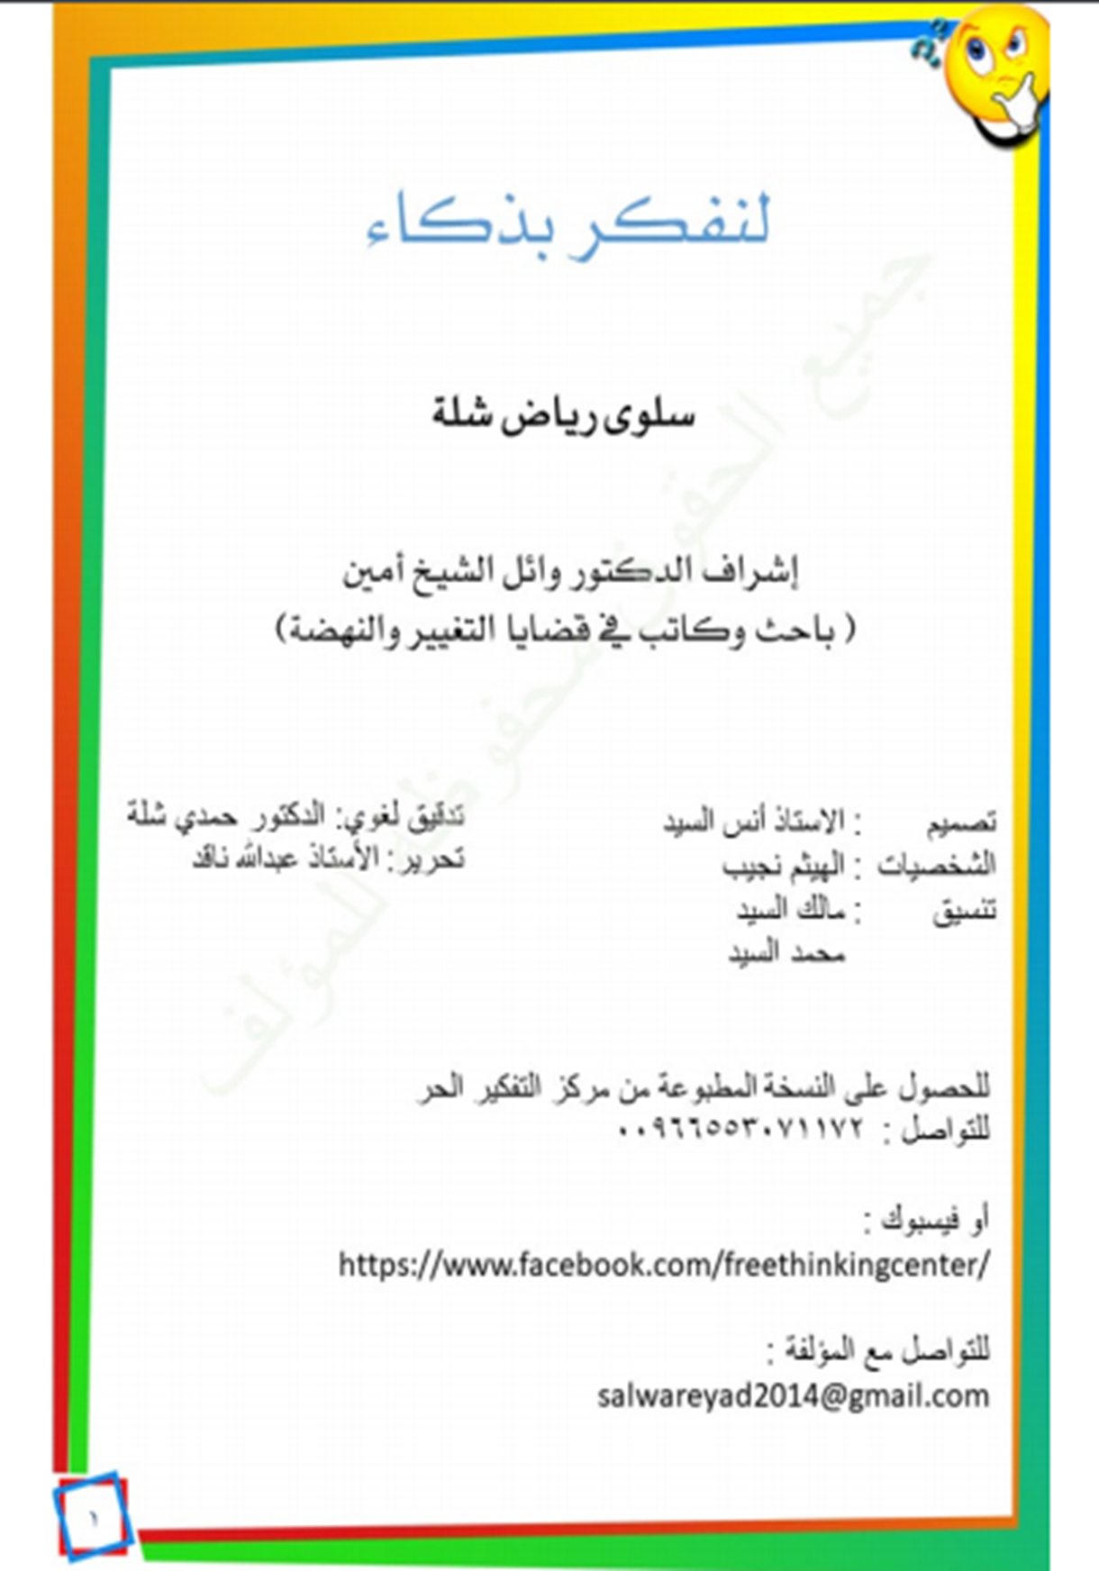

1

Dedication

To the youth who are embarking upon the adventure of life, with all of its trials and tribulations, its intellectual, ethical, ideological conflicts. To the youth whom we aspire they become wiser in building their perspectives of life and its vicissitudes, find their way in its mazes, suffering the least damage reaping as much benefit from it as possible; and rectify their way of thinking in understanding people and things around them.

To parents who are likely looking for a guide that is meant to raise awareness and help them to discuss with their children in a constructive and convincing way, thus providing them with a thinking method that would shield them against life’s pitfalls, especially following blindly the dictates of the press and of social media which are dominating our children’s minds and moulding their thoughts.

To educators of all kinds in schools and private clubs for boys and girls, educators who have accepted to bear the burden of trust, this book may help them in raising a vigilant generation that is conscious and aware.

To those who are willing to explore the methods of critical thinking, they can find in this book a brief introduction to this field of knowledge which can prepare them to study even more advanced and specialized books in the future.



2

Introduction

We would all like to be smarter, to have more understanding and knowledge; and we assume that the way to achieve that is by memorizing as much information as we can.

But that’s wrong!

To be smarter means your way of dealing with information is better and efficient.

To be smarter means your mind functions in a better way.

How can you achieve that?

This is what is known as the field of thinking skills, critical thinking being one of the most important skills. It is a complicated field that many people avoid studying because of the challenges its presents.

Writer, Salwa E-Chella, attempts to facilitate some of the critical thinking concepts with an amazing method, making this book your first step to enter the world of critical thinknig. She uses some interesting dialogues between two main characters to support her book.

“Moushakis”, the hasty boy and “Radjih”, the intelligent boy.

When you finish reading this book, I wish you will have had a lot of fun and enjoyment, and you would have become a smarter person. I hope you would apply what you will have learned from this book in your life.

**Dr. Wail Shaikh Amine**



3

Dear reader,

. I dedicate my book to you young and brilliant one, and I see you full of energy and life, tracing your future with diligence and hope which indicate you will have a promsing and frutful future by God’s will. However, the road to this future is full of experiences, difficulties and challenges. You will be exposed to situations that demand sagacity and intelligence, in order for you to be able to solve problems. You will need wisdom to take decisions, you will be the only one responsible for yourself, and you will have to bear the consequences of your decisions be them right or wrong. So how about train your mind on how to think properly in order to improve your competence, develop your talents, learn how to take the right decision, and solve problems?

There is a number of common mistakes that you may commit,; if you pay attention to them and train yourself to avoid them, your decisions will be more sensible and you will make it harder for others to fool you. Actually, not everybody wishes you the best; certain people will try to convince you of what they want just for the sake of their own interest! In this book, we have classified these common mistakes as “logical fallacies”. Critical thinking teaches us how to uncover these fallacies, and show us how to treat them through proper sensible thinking. It teaches us to look at the matter from different angles, so that our judgements would be more accurate and sound.

Moushakis, who has not learnt anything yet about critical thinking, will take us in a ride where he will trip over many logical fallacies as a result of his hastiness. Fortunately, our friend Radjih, is there to help him to correct these mistakes. So, let us watch their actions and behaviour, and see plenty of mischievous situations where Radjih will try his best to fix them..

**Let’s start together my friends...**