**Evaluation finale**

**Exercice 1 (5pts)**

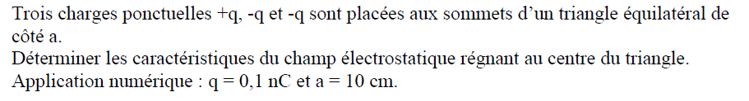

**Exercice 2 (5pts)**

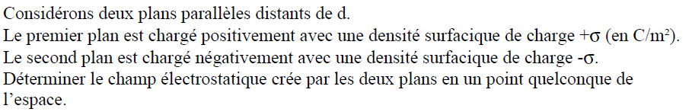

**Exercice 3 (10pts)**

