* Teacher‘s paper

|  |
| --- |
| 1H 30MIN |

|  |  |  |  |  |  |  |
| --- | --- | --- | --- | --- | --- | --- |
| 5MIN | 10MIN | 5MIN | 10MIN | 15MIN | 15 MIN | 30 MIN |
| Warm-up Quiz  (Question time) | The students read the text silently | The teacher reads the text orally | Answering questions about the text | 2 tasks about :  Articls  Prepositions | 2 tasks about :  Vocabulary  (semi-technical terms ) | Writing a letter to a friend |
| Presentation | | | | Practice | | Production |

By the end of this course, students will be able to gain knowledge about the vocabulary related to travel & tourism . students also will practice the following skills and functions :

* Reading for information
* Writing a cover letter

The grammar of this course includes :

* Articles
* Prepositions
* Time Table
* Detailed information.

The first 5 min :

Warm-up quiz : (question time ).

It is a warm-up activity which is used to give learners some idea about the lesson’s topic

It’s a technice used by (jun 2000) in order to break the ice and have the possible amount of information form students.

The next 10 min :

Students try to read the text silently and underline the ambiguous words.

After that the next 5 min :

The teacher reads the text orally and explains the underlined and complex words.

After digesting the text . (s \ t) try to get into the first practice which is a couple of questions about the text and by the end of this practice the part of presentation is over.

The second part of the course is Practice :

In the first 15 min :

Students will have 2 tasks in a shape of filling the gaps and true\false statment conserning the articles and prepositions.

And in the second 15 min :

Students will be exposed to 2 activities about vocabulary , to inhance their semi-technical terms which they use alot in the context of their studies.

Finaly , the last part which is Production :

Students and teacher play a littel game which contains a hat and small pieces of paper ,these papers has a name of a touristic city, than the student should write a letter to a friend inviting him\her to visit the place that he\she picked up from the hat , convincing him\her to consult the company that the student works in .

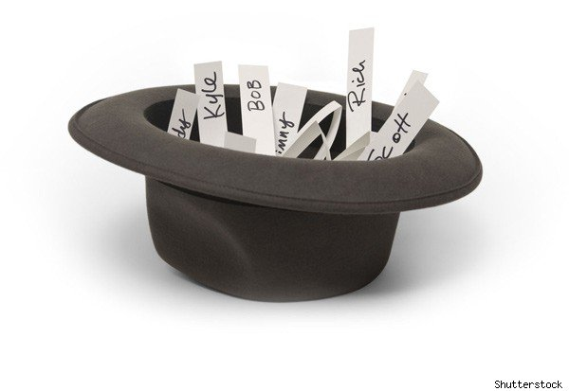

Assassi Messaoud G : 07 ESP homework

The Department Of Travel & Tourism

1st year lecture : 01



Part 1 :

Travel and tourism provide services of all types for both inbound and outbound travellers, and have become one of the world's fastest growing industries. International travel and tourism are the world's largest export earner and an important factor in the balance of payments of most nations. The market is increasingly diverse, covering not only traditional sunshine tourism and business trips but also many new types of travel that have developed in recent years. Tourism has become one of the world's most important sources of employment. It covers a wide range of jobs, including all branches of the travel industry, hospitality in hotels and restaurants, entertainment and recreation, as well as the tourist attractions in a particular region. Areas of work include Tour Operators, Travel Agencies, Tourist Boards and Tourist Information Centres, Transport Companies, Tour Guides, Tourist Attractions.

1.1After reading the text , try to chose the correct answer .

A

* For many countries tourism is an important source of income.
* Tourism is not an important factor in the economy of most countries.
* The travel and tourism industry is no longer growing.

B

* Travel and tourism means sunshine tourism and business trips.
* Travel and tourism means more than sunshine tourism and business trips.
* No new types of tourism have developed in recent years.

C

* The travel and tourism industry provides services only for incoming travellers.
* The travel and tourism industry provides services only for travellers who want to go abroad.
* Travel and tourism provide services for both of the above types of people.

D

* There are not many jobs in travel and tourism.
* There are a lot of jobs in travel and tourism but they are always of the same kind.
* There are a lot of jobs in travel and tourism and of many types.

Part 2 :

2.1.1 Fill in the space provided with the correct preposition

A t – to - Get into - get – On – from

* We can walk or go …..foot
* We arrived …….a small destination
* We ………….a private or public vehicle
* It took us an hour to ….. home.
* We travel ……. our place ….. our destination.

2.1.2Read the following text and insert the definite article *THE* where it is necessary or " /" (slash sign), where it is not.

* Haut du formulaire
* Bas du formulaire

  Travel Agencies are    link between travellers and companies selling holidays ,   transport and accommodation. Travel Agency Consultants advise customers, suggest   particular holidays or resorts and make booking arrangements either by   telephone or computer. They help travellers who do not want package holidays to plan   journey and then book air, rail or ferry tickets and accommodation. Their work involves  general paperwork and accepting cash, cheques or credit card payments. They also offer clients information about    passports, visas and vaccinations, and offer other services e.g. holiday insurance, travellers' cheques and foreign currency. Travel clerks are sales people and have to meet sales targets that    manager of    agency has set.

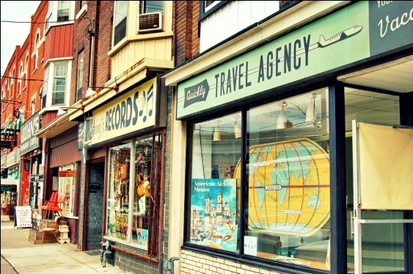 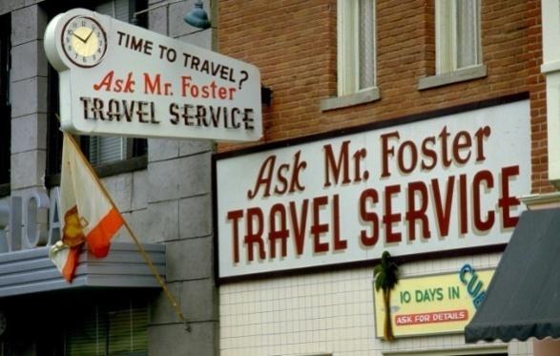

2.2Read the following text which tells us about tour operators and he importance of their possition

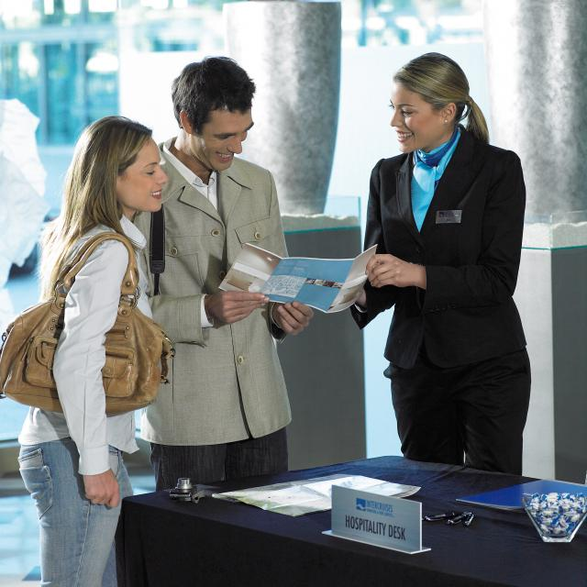 Tour Operators organise hotel bookings, flights, transfer arrangements and sell the tour as a package, either direct to the public or through a travel agency. They employ Representatives or Couriers to look after tourists. The couriers make sure that the travel arrangements run smoothly and deal with problems and emergencies as they happen. An important part of this job is liaison with coach drivers, ferry staff, customs and immigration officers, and with hotel staff at stopovers about accommodation and meals. They organise social activities, suggest excursions and give commentaries when travelling. Their work is usually seasonal. Hours are long and they spend most of the trip in the company of clients.

2.2.1 Now Choose the expression, A or B, that is closest in meaning to the word as used in the text.

BOOKING

a. reservation

b. accountancy

LIAISON

a. a romantic relationship

b. coordination and cooperation

COACH

a. a bus designed for long distance travel or sightseeing

b. a railway carriage

FERRY

a. a ship that transports passengers or vehicles across water

b. a place where goods are transported across water

STAFF

a. a group of officers in the armed services

b. people employed by a company or organisation

CUSTOMS

a. the place where goods and baggage are examined on entering a country

b. habits and traditions

STOPOVER

a. any kind of interruption or break

b. a place where somebody makes a break on a journey

2.2.2 Put ( voyage – journey- travel –trip ) in the space provided :

1. I'm going away tomorrow on a business .
2. How are you going to  ? By car or by plane?
3. The  over the mountains took a week.
4. Isabelle went on a long ocean  to Brazil.
5. Well, goodbye Hans. See you next week. Have a good .

3. write letter to a friend convincing him\her to visit the place that you picked, be an Operator and sell your product .