## All courses are prepared using many books and websites. “*Knowledge is found to be shared, but with respecting its sources*”

**Course: Logistics and Supply Chain Management**

## Lecture 7: Transportation

1. **Transportation meaning:**

* **Transportation**: was defined as the tool by which the market can be expanded, and well exploit the human and material resources which were not previously exploited, towards increasing production and improving its quality, as it helps in the transfer of goods and labor to places where they are more useful
* From a **logistical perspective**: **transportation** is one of the important economic functions which give the product the spatial benefit, as transportation refers to the movement of products from one location to another, from the beginning of the supply chain to the customer. Transportation is an important driver of the supply chain because products are rarely produced and consumed in the same location

1. **The importance of the transportation:**

* **At the level of organizations:**

The role that transportation plays in the logistics system is more complex than the transportation of goods. Where through a good transportation system, goods can be sent to the right place at the right time in order to meet customer demands in a manner that achieves the required efficiency, and it also builds a bridge between producers and consumers. Therefore, transportation is the basis for efficiency in logistics, and extends other functions of the logistics system. In addition, a good transportation system performance in logistics activities brings benefits not only to the quality of service, but also to the competitiveness of the organization

* **At the state’s level**: We find that the developed transportation sector contributes to the movement of progress which the national economy can reach through the following:

• **Contributing to the creation of competitive conditions:** by linking markets-which helps to create an element of competition between similar goods and services, in addition to providing some commodities which are not produced locally;

• **Achieving economies of scale in the field of production:** The expansion of markets as a result of the availability of transportation and shipping means helps organizations to benefit from economies of scale, in addition to choosing production centers which help the organization to benefit from some geographical advantages;

• **Reducing the costs of production**: Transportation costs are one of the elements of the total cost of production. If low-cost transportation and shipping methods are available, the production units can reduce the costs of the products at the lowest possible cost, and transfer them to other geographical areas;

• **Equal and stable prices**: Transportation helps to achieve equal and stable product prices by distributing products to places of increased demand.

* **At the community level:** The importance of transportation at the community level appears in:

• **Providing job**: Any increase in the tasks of this sector must be matched by an increase in the human resource, this means providing many job opportunities for various specializations;

• **Making social changes**: Transportation contributes to a large extent in making social change among members of society, by linking the countryside to the city or between countries through modern ways, which facilitate the process of communication that effectively contributes to increasing social development.

1. **Types of transportation:**

Transportation is divided into private transportation, public transportation, and mixed transportation **Private transportation:** is a service which is not available for use by the general public. Unlike a government-owned transportation service, the user bears the entire cost of the service provided directly without any subsidy;

* **Public transportation**: is indeed a shared passenger transportation service which is available for use by the general public. The total cost of these services is not borne by the user but is subsidized by the government. Public transportation mode includes: city bus, train, metro bus, subway, airline services, railway services, etc.

1. **Types of transportation means:**

Regardless of the type of transport, public, private, or mixed, there are several forms and types of means of transportation which allow to choose the appropriate means of transportation in terms of cost and speed, in addition to other criteria, in light of the determined objectives, characteristics and nature of each means, and the nature of the transported materials. The types of transportation’ means can be classified as follows:

* **Land transportation:** includes two means: railways (trains) and cars or trucks, and it includes:
* **Railways**: The greatest advantages of railways are represented in its speed and high capacity, so it has an important role in transporting passengers mainly in high-density areas, and with regard to transporting goods, it is the most effective means of transportation for materials such as: agricultural products, or raw materials such as: wood, coal, iron ore and building materials. However, it has some drawbacks as follows:
* Limiting its services to areas which have lines for it, therefore; it does not extend to many areas, especially small cities;
* Characterized by the relatively slow and long delivery period; due to the many points of train stops for unloading or adding other goods, etc;
* Lack of flexibility: means; it is restricted to certain lines which cannot be crossed.

Despite the mentioned negative aspects of the use of railways as a means of transportation, today it bears the largest share of the requirements of economic activity.

[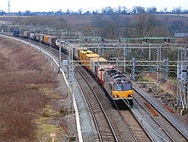](https://en.wikipedia.org/wiki/File:WCML_freight_train.jpg)

* **Trucks:** By analogy with railways, trucks are among the means of transport that are characterized by low fixed costs and high variable costs. Trucks, for example, do not require the extension of private roads, as is the case when building railways. Rather, these trucks rely on public roads available to all, and are characterized by the following
* It allows shipments to be moved from door to door, without the need for reloading or unloading;
* The services provided by heavy means of transportation are characterized by flexibility, as they are available at any time, continuously, and at any moment the organization needs.
* The organization can contract with other organizations specialized in the transportation process, thus; it transfers the transportation and freight services to them, under the appropriate circumstances without incurring capital expenses and administrative problems associated with the organization's ownership of its own transportation fleet.
* **Air Transportation:** it refers to the activities surrounding mechanical aviation and the aircraft industry. Aircraft industry includes fixed-wing and rotary-wing types of aircraft, as well as lighter aircraft such as balloons and blimps ,which are used to transport expensive, lightweight cargo. Among its advantages: saving time and high speed in implementation, but its drawbacks are: high costs due to: aircraft consumption of large quantities of fuel, high costs of periodic maintenance of devices, and costs of safety needs that must be provided in the aircraft...etc.

[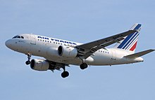](https://en.wikipedia.org/wiki/File:Airfrance.a318-100.f-guga.arp.jpg)

* **Water transportation**: It is considered as an inflexible means because it depends on the availability of water bodies from the seas and large rivers, but it is highly efficient in terms of load volume, which reaches thousands of tons for goods and people, and it is also the cheapest means of transportation, so it is usually used to transport Petroleum and heavy equipment.It is divided into river transportation and sea transportation :
* **River transportation**: It is considered as one of the most important means of transportation used in the case of large-sized commodities such as: coal, iron, steel, cement, and others. These commodities are characterized by their low value (compared to their size), and they are not subject to damage factors, therefore their storage costs are low, that enables to ignore the time element for benefiting from the low cost rate.

[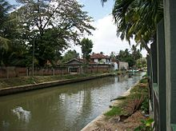](https://en.wikipedia.org/wiki/File:Negombo_canal_2.jpg)

* **Maritime transportation**: There are two basic means of marine transportation:
* **Domestic transportation or transportation by boat**: This method is considered as the best in transporting large-sized and low-value commodities such as: iron, building materials, grains, etc., and it is approved internally;
* **Marine carriers**: They are large ships that roam the seas and oceans and are used to transport goods between one country and another. The cost of transportation by them is usually higher than the cost of transportation by boat, in relation to the ton / mile. These carriers are specialized in transporting minerals or metallic properties, liquid gases, chemicals, etc. In addition to the various other goods that are represented in the country's exports.

The advantages of water transportation stand out in the following points:

* The low cost of this means is its most important advantage compared to other means of transportation;
* This means is particularly suitable in the case of commodities which are shipped in huge quantities, and which can be loaded and unloaded by mechanical means, such as: petroleum, coal, wheat, timber, building materials, etc.
* It is suitable for very long distance transportation between continents and countries.

In the contrast, it has some disadvantages as addressed below:

* The length of the transportation process through this means, therefore: it is not suitable for emergency conditions;
* Decreased flexibility: which requires to use another means of transportation to transport goods from the port to consumption or storage centers.
* It is influenced by the climatic and atmospheric conditions and the state of seas and rivers

[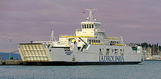](https://en.wikipedia.org/wiki/File:Jadrolinija_supetar_ferry.JPG)

* **Pipelines**: are regarded as one of the most important means of transportation, especially over long distances, but they are only suitable in the case of commodities of a liquid or gaseous nature. For this reason, we find that the use of pipelines is almost limited to transporting crude oil, petroleum products, and natural gas only.. We state below some pipelines advantages :
* The transfer process takes place 24 hours over a week;
* Compete with other means in terms of time and cos;.
* Pipelines are not affected by weather conditions;
* Low volume of losses due to the nature of the transported materials.

In the contrast, pipelines transportation has some defects as the following:

* It has a high fixed costs and low variable costs, due to: the exorbitant costs required to the extension of pipelines, in addition to the standard specifications required in terms of quality and extreme accuracy in the methods of extending pipes;
* It also requires a skilled workforce to ensure maintenance to prevent leaks or explosions which may occur.

[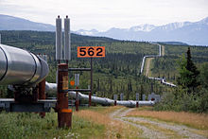](https://en.wikipedia.org/wiki/File:Trans-Alaska_Pipeline_System_Luca_Galuzzi_2005.jpg)

1. **Coordination between means of transportation :**

The most important formulas of this coordination, we state the following

* **Birdy back” service:** Where trucks (trailers) unload or deliver their cargo from airports, while planes carry out long-distance transportation, usually between several countries.

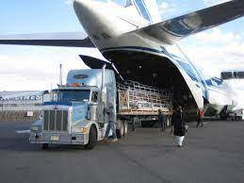

* **Piggy back” service**: It is the service of transporting trucks or trailers on railway cars. The most important form of this service is the combination of transportation by rail and transportation by truck. This helps the shipper to have the advantage of door-to-door transportation from one hand, and the advantage of cost reduction and rapid transportation on the other hand, which are two advantages that cannot be achieved by any single means.

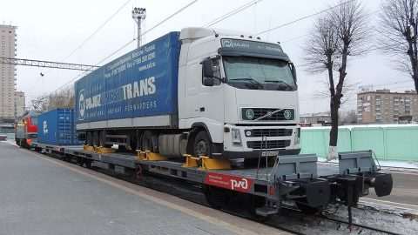

* **Fishy back**: this is combination of water ship to truck (road) transportation where goodsare shifted from anyone of the two to another. It is carried out by transporting railway cars loaded with trucks on ships, and through this formula for coordination, three types of transportation are combined, which are land transportation (trucks), sea transportation, and rail transportation at the same time, and without the need to unload the goods at any of these stages, as there are ships equipped to carry out this type of service.

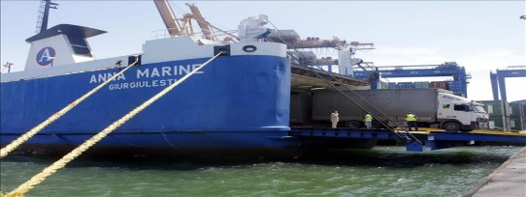

1. **Criteria for differentiation between means of transportation:**

Transportation requirements can be met in three basic ways as follows: Firstly; a private fleet of equipment may be operated. Secondly, contracts can be arranged with transportation professionals. Thirdly, an organization may engage the services of a wide range of transportation companies which offer different transportation services as needed on a per shipment basis.

In logistics system, there are three primary factors for transportation performance: (1) cost, (2) speed, and (3) consistency. **Transportation cost**: means the payments for freight between two geographic locations and expenses related to maintaining inventory in transit. Logistics systems should use transportation means which reduces the total cost of the system. This may mean that the least expensive means of transportation may not result in the lowest total cost of logistics. **Transportation speed**: is the time required to complete a movement. The speed and cost of transportation are related in two ways. First, carriers which are able to provide faster service usually charge higher costs. Secondly, the faster the transportation service, the shorter the interval during which the inventory is in transit and not available. Thus, one of the crucial aspects in selecting the most desirable means of transportation is striking a balance between speed and cost of service. **Transportation consistency**: refers to the differences in the time required to perform a given movement on a number of shipments. Consistency reflects reliability of the transportation.

One of the main tasks of the logistician is to make a comparison between the different means of transportation, as well as the type or model of that means.

There is a set of criteria in making a comparison decision, the most important of which are as the following:

* **Speed**. The ability to move product from one point to another as quickly as possible. Where speed provides the marketing benefit of time to distribution and ensures the benefit of space. In detail, the speed of a transportation means can be defined as the time required to transport the product from the source of production to the terminal, load the product onto the transportation means, pass the end point, and deliver the products to the receiving station.
* **Completeness**. It means the ability of a means of transportation to move stock from one location to another without using other mediums. This is crucial because the fewer materials which have to be handled between the point of origin and the point of destination, the lower the transportation cost and the shorter delivery time.
* **Reliability**. The concept of reliability refers to the extent of confidence and the ability to achieve regularity in the supply process by transportation means. Both the time factor and reliability affect the cost of storage, including the cost of sales opportunities which were lost due to the unavailability of the commodity, in addition to its impact on the level of service provided to customers. This affects the degree of efficiency of the organization's physical distribution system.
* **Capability**. refers to the ability of a particular means of transportation to accommodate a given transport load. The driving factor is the nature of the product. Characteristics such as product type (liquid, solid, bulk or package), weight, dimensions and load size will have an impact when deciding on material handling equipment capacities and the mode of transportation. For example, when transporting liquids, tank cars and pipelines will be the most suitable transportation means.
* Frequency. This performance factor is a measure of the frequency a given transport mode can pick up and deliver. Generally, the shorter the transport interval the greater the flexibility of the mode to respond to channel requirements. More frequent transport also decreases the required modal size and the magnitude of the inventory to be transported.
* **Cost**. Although market time and place utilized are critical elements of transport mode selection, the costs in transportation. The most obvious costs is the rate paid to the carrier for use of the mode itself. Other indirect costs are labor and material handling to load and unload the carrier, occurrence of spoilage and damage, insurance to protect against possible loss, and in-transit inventory carrying costs paid by the shipper.

Furthermore;

* **Safety**: The arrival of the goods in the same conditions and specifications in which they were shipped reflects the level of safety of the means of transport. Although the transported goods may be insured whether against the risk of theft, damage, loss, or breakage...etc., the occurrence of these risks may affect the the relationship with customers, as it may affect the cost of inventory in case of precaution for these circumstances.
* **Nature of the commodity**: If the commodity is low-priced and large-sized raw materials, so; the best way to transport it is by land or sea. But if the commodity is liquid and its quantity is large, such as oil, it can be transported by pipelines, by sea, or by trucks (tanks).
* **The financial capabilities of the organization**: organizations with limited financial resources resort to means of transportation that have a low cost, especially since such organizations do not have their own means of transportation, while organizations which have great financial capabilities, even if they don’t have suitable means of transportation, they are able to rent them from others, and they can adopt the appropriate means according to the surrounding circumstances.

Generally; the organization must balance between these factors. The table below presents the classification of the various means of transportation in terms of criteria for comparison between them:

**Table: Classification of means of transportation in terms of different comparison criteria**

|  |  |  |  |  |  |  |
| --- | --- | --- | --- | --- | --- | --- |
| Cost | Speed | Reliability | Capabilities | Market Coverage | Security | Fastest average delivery time |
| Air transportation | Air transportation | Pipelines transportation | Maritime transportation | Trucks | Pipelines transportation | Railways |
| Trucks | Trucks | Trucks | Railways | Railways | Maritime transportation | Trucks |
| Railways | Railways | Railways | Trucks | Air transportation | Railways | Maritime transportation |
| Pipelines transportation | Pipelines transportation | Air transportation | Air transportation | Maritime transportation | Air transportation | Pipelines transportation |
| Maritime transportation | Maritime transportation | Maritime transportation | Pipelines transportation | Pipelines transportation | Trucks | Air transportation |