Mohamed Kheidar Biskra University - Faculty of Exact Sciences, Nature and Life
Department of material Sciences

The first semester / the scale is chemistry / Mrs. Madoui Nadia
Rules of work and safety in the chemistry laboratory with the display of laboratory utensils

1 Getting started with practical work
In the field of chemistry, there are safety methods and rules that allow us to perform work in complete safety in the laboratory, allowing correct and accurate results to be obtained. In addition to these rules, a good knowledge of the equipment used in the laboratory is essential for the good progress of the work.
2- Practical work objectives:
Identify hazards and safety precautions in the chemical laboratory
Learn about the most important laboratory tools and how to use them
Security rules
Safety instructions to be followed in chemistry laboratories
Do not enter the laboratory without permission
Wear a long, buttoned cotton apron, not polyester (cotton burns if it comes into contact
with flame, as polyester melts and sticks to the skin)
Tie the hair back if it is long for the girl
Wear eye protection and gloves when handling corrosive products
Leave the corridors empty in the laboratory and movement is strictly prohibited during
practical work
Put equipment away as soon as it becomes unnecessary so that it does not get in the way.
During the next steps, also learn how to manage your work space and time
Immediately clean up any product, liquid or solid, that falls on the counter or on the floor.
Practical laboratory work must be conducted with the student standing
You must have knowledge of personal work and the work of your colleagues and be aware
of the risks it can present.
Never point a test tube at yourself or anyone else while warming or testing. Never look at
the test tube axis
All bottles without exception must have a label on which we find the name, formula, safety
chart(s).
Read the instructions for a commercial product or bottle
Any accident and any breakage or damage to the equipment must be reported immediately
to your professor
If you burn yourself or if the product gets on your skin and eyes, immediately wash the
affected area with water
Never pour water over a concentrated acid solution.
At the end of the application work, empty all containers, rinse and put away the dishes, fill
the burets with distilled water and clean the work surface.
Use clean equipment in good condition
Wash your hands before and after applied work
Label vials and containers clearly
Respect the safety instructions given by the professor.
Read the safety illustrations on chemical bottles before using them
Prohibitions
Never eat, smoke or drink in the laboratory
Do not suck by mouth
Never inhale a chemical
Do not handle chemicals directly with your fingers or taste them

Symbols used in chemical labels

Safety Instructions | مدلول signification | code  Pictograph
Consumption, inhalation, and skin contact should be avoided by wearing gloves and a nose mask | Toxic (T)  Very toxic (T+)  Toxic and lethal to living organisms
Inhalation and skin contact should be avoided by wearing gloves and a nose mask. | ضار(X_{n}) noxious  مثير و مهيج Irritating (Xi)  A substance that causes irritation to the skin and eyes
It must be kept away from sources of flame. Close the bottle well and quickly after use | سريع الالتهاب fast inflammation (f)  شديد الالتهاب) (F⁺ Extrêmement
It must be kept away from combustible materials, used in isolation from fire and sources of electricity | محرق ) (O Oxidizer  A substance that helps with inflammation
You should avoid any contact with skin, eyes, clothing, and wear an apron and gloves. | Corrosive (C)يسبب التآكل  A caustic and burning substance that causes damage to skin and clothing
It should be used away from flames, heat sources, and avoid shocks | قابل للانفجارExplosive (E)
It must not be thrown into the sink or in the trash, but rather in special containers for that. | يلوث البيئة Pollutant (N)  A substance that pollutes the environment and poses a threat to animals and plants

The graduated cylinder  L'éprouvette graduée  مخبار مدرج | The stemmed glass  Le verre à pied  زجاجة بقاعدة |  | The Erlenmeyer flask  L'erlenmeyer  إرلينة |  | the beaker  le bécher  بيشر |  | Tube à essais  Test tube  أنبوب إختبار
The glass stirrer  L'agitateur en verre  خلاط زجاجي | The volumetric flask  La fiole jaugée  حوجلة حجمية |  | The volumetric pipette  La pipette jaugée  ماصة حجمية |  | The graduated pipette  La pipette graduée  ماصة مدرجة |  | La burette graduée  سحاحة مدرجة
La pipette graduée  The pro-pipette  (poireaspirante)  ماصة | The watch glass  Le verre de montre  زجاجة ساعة |  | L'entonnoir  The funnel  قمع زجاج |  | The separating funnel  L’ampoule à décanter  قمع الفصل أوالترشيح |  | Le ballon à fond rond  دورق كروي القاعدة
pH-mètre  pH meter  PH مقياس | Balance électronique  Electronic scale  ميزان كهربائي |  | L'agitateur magnétique  The magnetic stirrer  خلاط مغناطيسي |  | The tank heater (electric)  Le chauffe ballon (électrique)  مسخن دورق كهربائي |  | The wash bottle  La pissette  قارورة غسيل
Noix  Nut  مثبت |  | Pince  Spoonbill  كماشة |  | Bouchon  Spoonbill  غطاء فلین |  | Spatule  Spoonbill  ملعقة مخبرية
Support élévateur  Lift support  داعمة للرفع |  | Valet  pregnant  حامل |  | pipette automatique  automatic pipette  سحاحة أوتوماتكية |  | Potence  Gallows  حاملة سحاحة
Compte-gouttes  Dropper  قطارة |  | Bec Bunsen  Bunsen burner  موقد بنزن |  | Pince en bois  Wooden clamp  المشبك الخشبي |  | boite de pétrie  petrie dish  علبة بتري
Cristallisoir  Crystallizer  وعاء التبلور |  | Entonnoir Büchner  Büchner funnel  قمع بوشنر |  | Mortie et pilon  Mortar and pestler  مدق |  | Creuset  Crucible  بوتقة
Papier filtre  Filter paper  ورق الترشيح |  | Réfrigérant droit  Straight refrigerant  مكثف |  | Réfrigérant à boules  Ball cooler  مكثف |  | Colonne de Vigreux (ou colonne à distiller)  Colone into the distiller  مكثف

Safety illustrations

Laboratory equipment and uses
Measuring volumes requires high accuracy
Conducting a chemical experiment requires the use of a number of tools (utensils and devices), some of which are used to store or carry chemicals. Measuring the volumes of liquid solutions or measuring a physical property such as weight, temperature, etc. It is necessary to know the purpose of using each of them, as well as using them correctly.
Most of the vessels used in experiments are made of glass - high-quality Pyrex glass - therefore they must be used with caution to preserve them from crushing, Because it is made of glass, it allows a good reading of the volume and monitoring of all the course of the experiment, such as a change in color, the appearance of a precipitate, or the release of gas...etc. Glassware can be divided into three categories:
General tools
For general use that does not require precision in measurement such as Becher, Arlene, test tube, container, etc.
Tools included
For precise use )requires accuracy in measuring volumes (such as a graduated tester, graduated pipette, burette, etc.
Goji Tools
For high precision use that requires high accuracy in volume measurement, such as Goji flask, Goji pipette, with one or two lines, etc
Note
The correct and accurate reading on volume measuring tools is as shown in the figure, such as a graduated tester.

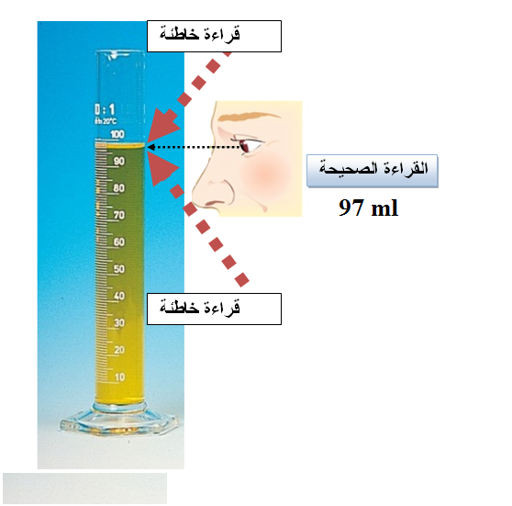

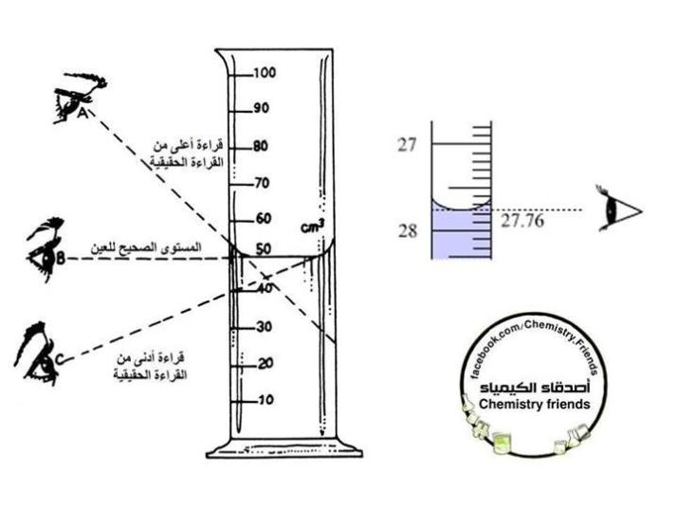

The correct way to read a buret
When reading the graduations in the buret, the eye of the observer must be at the level of the surface of the liquid in order to avoid a difference in reading error. Even the thickness of the lines printed on the buret plays a role in this.
Correct reading is done
That the bottom of the concavity of the liquid is touching the top of the line of the degree you want to measure, as in the corresponding picture in the case of transparent solutions.
In the case of highly colored solutions, where it is difficult to read at the concavity, it is read at the upper surface.
The burette must be placed vertically when reading, as the holder is placed on a flat, firm surface, and a white sheet of paper is placed behind the scale for accurate reading.

