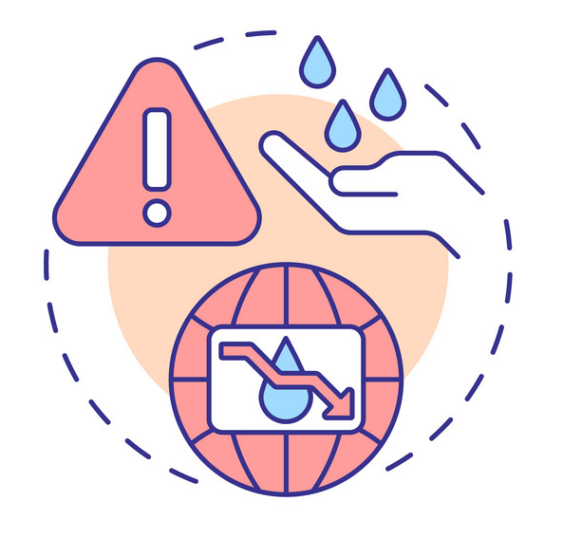
Unit 02

Water Stress: Scarcity Threats

«Water is a very good servant, but it is a cruel master»
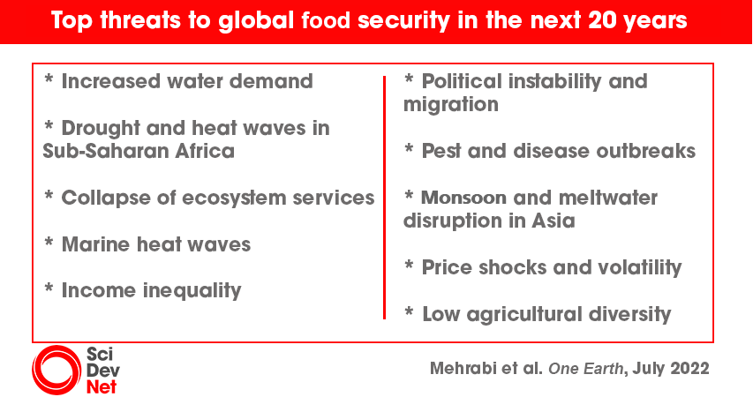
C.G.D. Roberts, "Adrift in America", 1891

Objective
- In this course, the second unit, following the previous one’s environmental topic, introduces another crucial issue of water crisis in the world. Discussing such worldwide matter, this unit, in the activity of language development, reviews the major active listening skills which will help language learners to create new visions towards analyzing sources of knowledge and pave the ways towards communicating problems and solution.
Aims
- Reviewing active listening skills
- Interacting with reading and listening materials
- Eliciting the use of informative language
- Communicating problems and solutions
Outline
- Activity one: Discussing unit quote and questions
- Activity two: Analyzing an article
- Activity three: Reviewing active listening skills
- Activity four: Analyzing an audio clip
- Activity Five: Computerized-dynamic assessment via Moodle

Activity one: classroom discussion
Discuss with your classmates the following questions:
- Rethink the role of water and provide valid examples or related quotes you remember from our culture
- Read the quote by Roberts, how can water be a servant and a master?
- How to avoid cruelty of water when becoming a master?
- Imagine that we currently have a water crisis, describe the results of such problem on your life.
Activity two: Analyzing an article
Read the following web-article and answer the follow-up questions

Water scarcity

Addressing the growing lack of available water to meet children’s needs.
Even in countries with adequate water resources, water scarcity is not uncommon. Although this may be due to a number of factors — collapsed infrastructure and distribution systems, contamination, conflict, or poor management of water resources — it is clear that climate change, as well as human factors, are increasingly denying children their right to safe water and sanitation.
Water scarcity limits access to safe water for drinking and for practising basic hygiene at home, in schools and in health-care facilities. When water is scarce, sewage systems can fail and the threat of contracting diseases like cholera surges. Scarce water also becomes more expensive.
Water scarcity takes a greater toll on women and children because they are often the ones responsible for collecting it. When water is further away, it requires more time to collect, which often means less time at school. Particularly for girls, a shortage of water in schools impacts student enrolment, attendance and performance. Carrying water long distances is also an enormous physical burden and can expose children to safety risks and exploitation.
Questions
- Draw a table showing causes and results of the crisis
- Discuss in groups possible strategies to avoid this crisis
Activity three: Active Listening Strategies
Active listening results in gaining the skills to make a successful conversation. It helps to draw meaningful information during conversation either written or spoken. The basic aim of active listening is to understand the speakers’ attitude and perspective in order to build knowledge and/ respond accurately and appropriately to the assignment.
General steps to take for a successful active listening
- Ask open-ended questions
- Remain focused attention towards the main topic discussed in the audio/video
- Try to link the audio’s main topic and detailed information and your assignment purpose
- Be attentive to ideas and problem-solving opportunities
- Listen for both attitudes and content
For this course we will focus on two steps in each of the processes of active listening
Stage 1: Pre-listening
Sub-skill 1: Motivation
Try to rise curiosity and suggestions about the topic
Sub-skill 2: Contextualization
Understanding the difference between the context
Stage 2: During- listening
Sub-skill 1: Focused attention
The details used to explain the topic and focus on body language in case of video and the use of intonation to understand the attitude of the speaker as non-verbal cues
Sub-skill 2: Questioning
Asking questions, seeking clarification, while listening will help in monitoring the attention and the comprehension, the listener will not be passive
Stage 3: Post-listening
Sub-skill 1: Reaction
Focusing on the language used to express different ideas and different attitudes referring to previous knowledge
Sub-skill 2: Summarizing
Focusing on producing a concise overview of the main ideas in the audio/video
Activity Four: Analyzing an audio clip (assignment to be submitted due ….)
Watch the episode produced by Netflix about “World’s Water Crisis” on https://www.youtube.com/watch?v=C65iqOSCZOY.
Provide a summary of the remarkable points in the episode.
Activity Five: Computerized-dynamic assessment via Moodle

